Data Structures and Algorithms mini project report
on

C-Powered Music Player

SUBMITTED BY
Name  Hriday Shah  Shubham Shah | SAP ID Roll no.  60002240081 E0114  60002240102 E0115

DEPARTMENT OF
ELECTRONICS AND TELECOMMUNICATION ENGINEERING
Academic Year: 2025-2026

Shri Vile Parle Kelavani Mandal’s

Dwarkadas J. Sanghvi College of Engineering
Plot no. U-15, JVPD Scheme, Bhaktivedanta Swami Marg,
Vile Parle (W), Mumbai – 400 056

PROJECT TITLE1:
C-Powered Music Player

SOFTWARE LANGUAGE USED:
• Backend / Core Logic: C
• Frontend / User Interface: Python (Tkinter module)

THEORY/METHODOLOGY:
This project applies core Data Structures and Algorithms (DSA) to architect a high-performance, cross-platform music playlist manager and audio player. By isolating the data processing to a C backend and the graphical interface to a Python frontend, the project successfully implements a modern, decoupled software architecture. The underlying methodology heavily relies on the following core concepts:
1. Data Structure Design: Doubly Linked List (DLL)
A Doubly Linked List serves as the foundational data structure for playlist management in the system's dynamic memory. Unlike static arrays, the DLL allows for the dynamic allocation of memory (malloc) only when a new song is added, preventing memory waste. Each node in the list corresponds to a unique track and holds data strings (Title, Artist, Filepath) and an integer (Duration). Furthermore, the prev and next pointers native to a DLL perfectly model a real-world media player, allowing for bidirectional traversal. Skipping to a previous or next track operates at a time complexity of $O(1)$, which is highly efficient.
2. Searching Mechanism: Linear Search with String Manipulation
To allow users to find specific tracks, a Linear Search algorithm is implemented. Because linked lists do not store nodes in contiguous memory locations, index-based algorithms like Binary Search cannot be used. The Linear Search traverses the list from the head pointer, operating in $O(n)$ time complexity. To ensure a robust user experience, the methodology incorporates a custom string-matching function using <ctype.h> to convert both the user query and the node data to lowercase at runtime, effectively making the search case-insensitive.
3. Sorting Algorithm: In-Place Bubble Sort
The project features dynamic sorting, allowing the playlist to be ordered alphabetically by title or numerically by track duration. To sort the linked list, a modified Bubble Sort algorithm was developed. While standard Bubble Sort operates at $O(n^2)$ time complexity, this implementation optimizes memory usage by achieving an $O(1)$ auxiliary space complexity. Instead of utilizing heavy pointer manipulation—which risks breaking the prev and next chains—the algorithm swaps the inner data payload (strings and integers) between adjacent nodes while leaving the structural pointers completely intact.
4. Inter-Process Communication (IPC) and Multithreading
To bridge the C backend with the Python frontend, the methodology utilizes Inter-Process Communication. Python’s subprocess module launches the compiled C executable as a hidden child process. Python then pipes user inputs from its graphical buttons directly into the C program’s Standard Input (stdin). To prevent the Python GUI from freezing while waiting for the C program to process data, a background daemon thread is spawned using Python's threading library to continuously read the C program's Standard Output (stdout) asynchronously.
5. Directory Parsing and OS Integration
The C backend leverages the <dirent.h> library to programmatically scan local system directories for .mp3 files, automatically populating the linked list without manual data entry. Playback is achieved by capturing the absolute file path and using the system() function to trigger the host Operating System’s default media player natively.

RESULT:
The application successfully initializes a responsive Graphical User Interface (GUI) that seamlessly drives the C-based algorithms in the background. The dynamic memory allocation handles playlists of varying sizes without memory leaks, successfully tracked via custom garbage collection (free() traversal) upon exit. The integration of absolute path anchoring resolved common FileNotFound errors, allowing the auto-loader to successfully detect and inject entire directories of .mp3 files into the Doubly Linked List. Furthermore, the IPC bridge successfully passes commands instantly, proving that the two languages can operate in tandem to search, sort, and play audio files across different operating systems (Windows/Unix) without execution delays.. 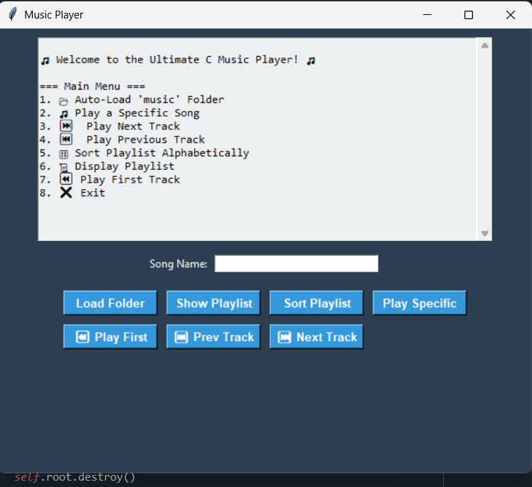
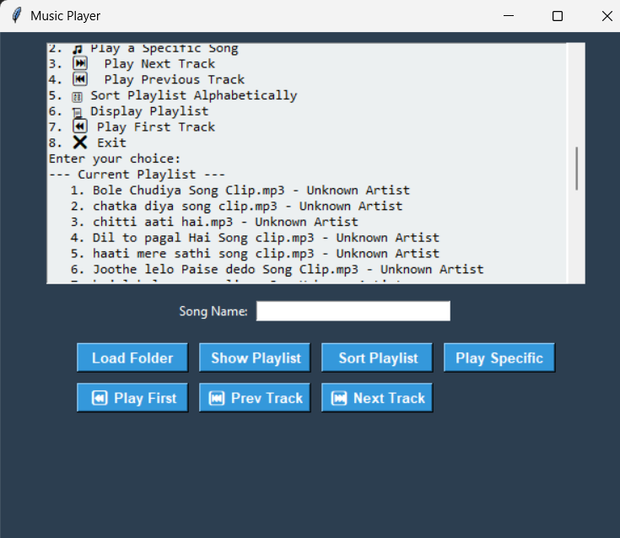

CONCLUSION
This mini-project successfully demonstrates that foundational data structures like Doubly Linked Lists are highly practical and effective for managing sequential, dynamic metadata such as music playlists. By combining standard algorithms with Inter-Process Communication, the project bridges the gap between low-level memory management in C and modern user experience design in Python.
Future Scope: While the current build successfully manages playlist logic and triggers the OS media player, future iterations of this project could eliminate the reliance on the system() command by integrating native audio-decoding libraries (such as SDL2 or Miniaudio) directly into the C backend. Additionally, file I/O operations could be expanded to allow users to save their dynamically generated playlists to a .txt or .csv file, ensuring data persistence between application sessions.

